1. Provide a screenshot to show that you successfully created the Docker *container* namedubuntu_container.

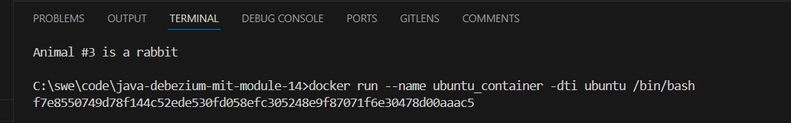

1. Provide a screenshot to show the ubuntu_container command line interface.

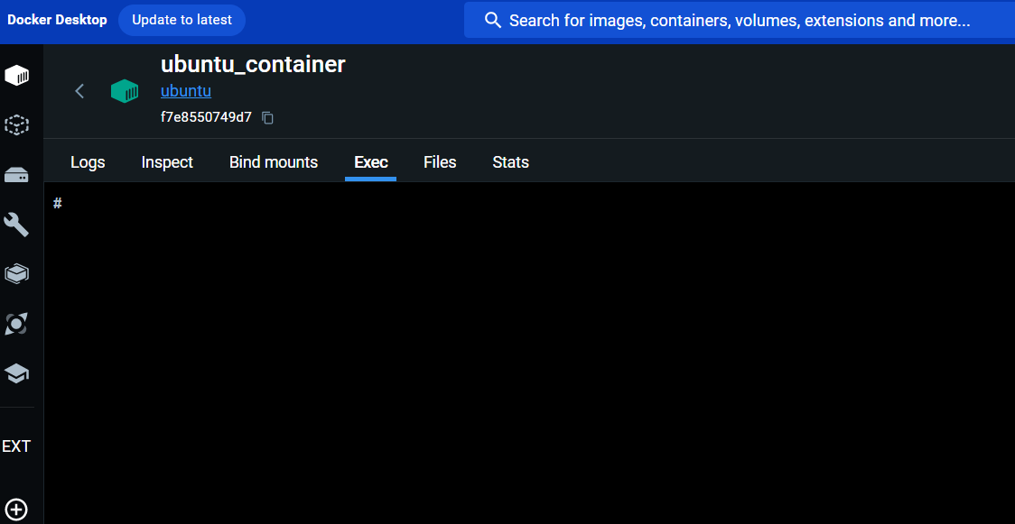

1. Provide a screenshot to show that the container_activity_14.1 folder has been created with a file in it titled container1.txt.

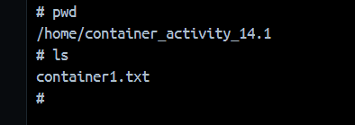

1. Provide a screenshot to show that the container_activity_14.1 folder has been created and that it contains the container1.txt file with the “Hello World” content added to it.

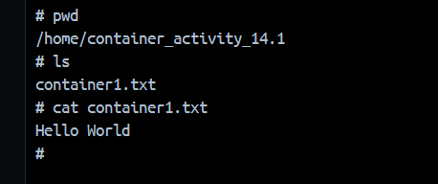

1. Provide two screenshots. Provide one screenshot to show that you created the local_activity_14.1 folder. Provide a second screenshot of your command line interface to show that you successfully changed your folder to the local_activity_14.1 folder.

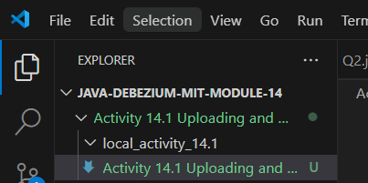



1. Provide a screenshot to show that the docker cp command was executed successfully and there were no errors after copying the container_activity_14.1 folder.



1. Provide a screenshot of the folder to show that you successfully copied the container_activity_14.1 and its files folder to the local_activity_14.1work folder.

